Project 1 – Panorama final report

Author:

Pavel Vahrushev 319606174

Introduction:

The problem is when given a set of images from rotating or moving camera to combine the distinct information provided in them into a single panorama image.

The goal is to perform automatic panorama generation.

The panorama is based on the assumption that different images are related only by rotation of the camera and therefore the motion (or transformation) between the images can be accurately modelled by homography.

In my approach I’ve implemented the algorithm provided with the project.

The input of such an algorithm is a sequence of images horizontally scanning (due to camera rotation) different parts of a scene, with significant overlap in the field of view of consecutive frames. The output a large image of the scene in which all these input images have been combined.

Approach and Method

The implementation is as follows:

1. Assume that images of the scene are provided from left to right meaning that the first image has the leftmost part of the scene and last the rightmost and the images are ordered properly from left to right.
2. For every two images we extract features using SIFT algorithm

The **scale-invariant feature transform (SIFT)** is a feature detection algorithm in computer vision to detect and describe local features in images.

In general, simple corner detection techniques can work well to find interest points in any image but when you have images of different scales and rotations, you need to use scale-invariant feature detection for image stitching.

1. Afterwards, using the points from 2 we compute the homography between the two images using RANSAC algorithm and store it in the appropriate index in H, a homography list.
2. Display a graphical representation of the points that were matched
3. Afterwards we chose the medium image to be the coordinate system and morph other images to it by multiplying homographies to morph every other image to that system.
4. By doing so I can also determine the size of the final panorama image by checking the corner coordinates of every image morphed to common coordinates system.
5. Split the final image by averaging the centers of each image pair.
6. Apply the values of each morphed image onto its’ designated area.
7. Store the result panorama

Results

Here are the results of applying the algorithm onto the sample images provided by the project:

Backyard

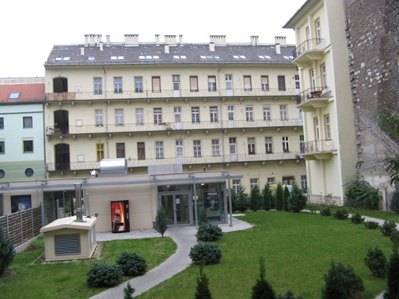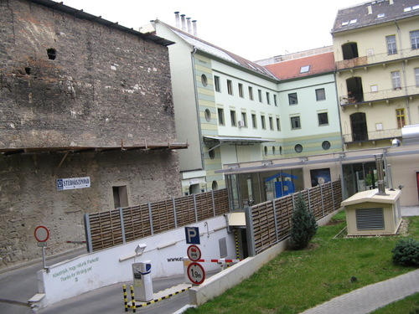

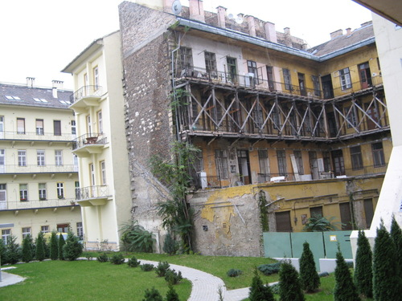

Key points: 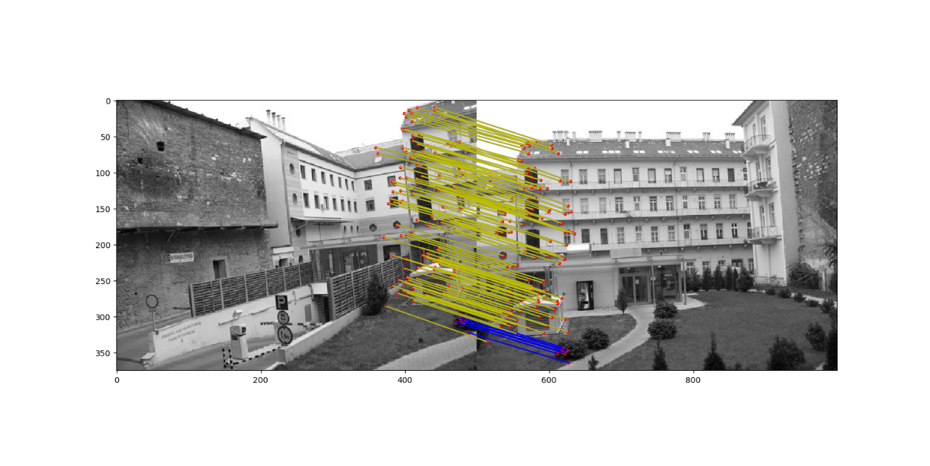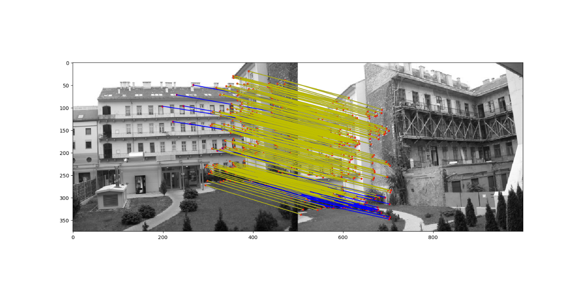

Result:

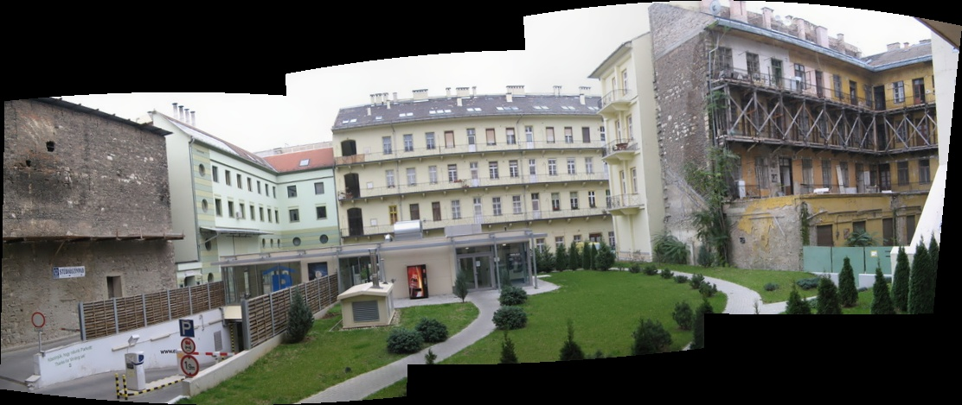

Oxford: 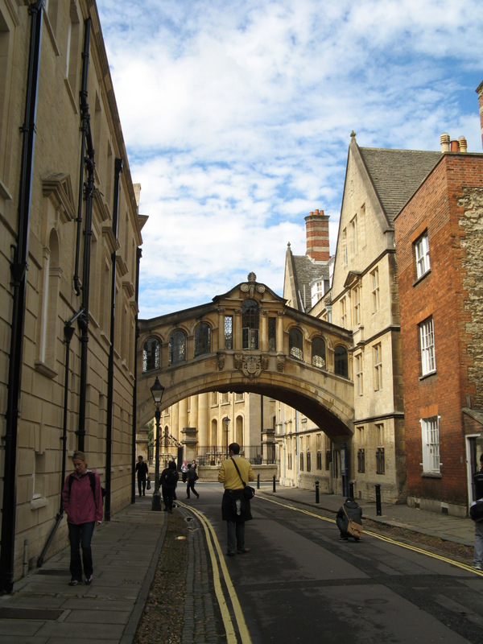

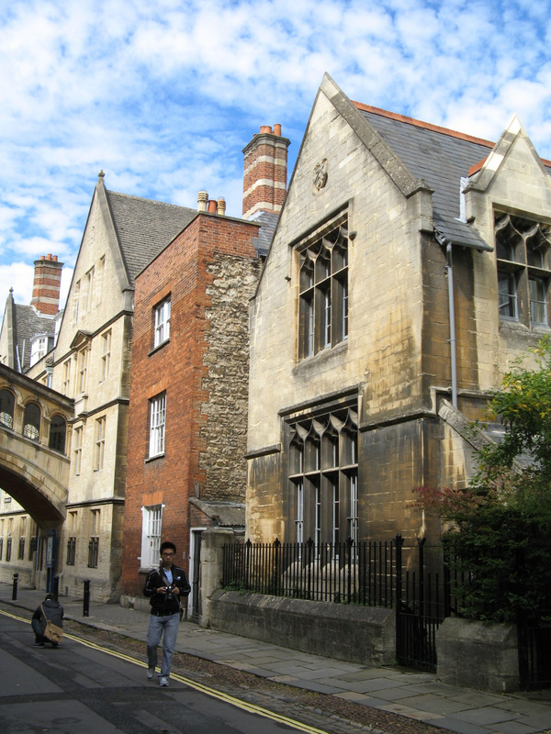

Key points:

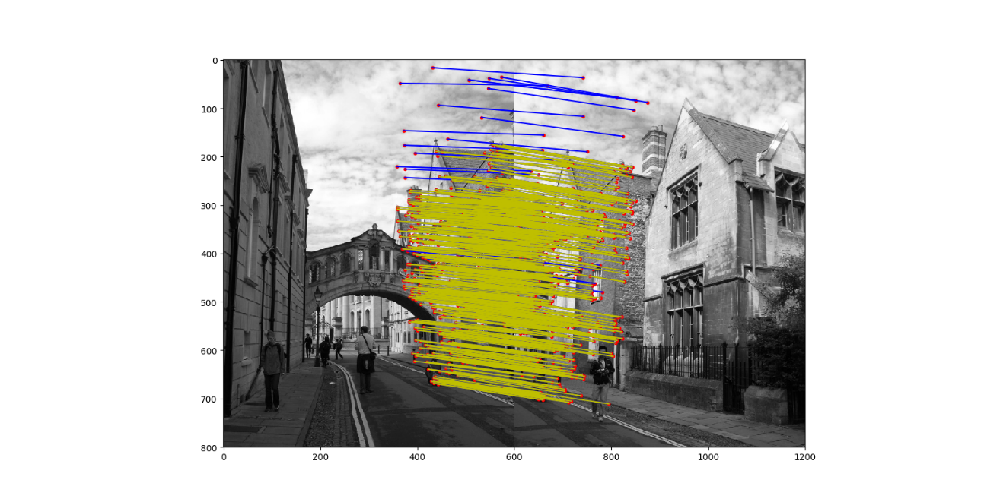

Result:

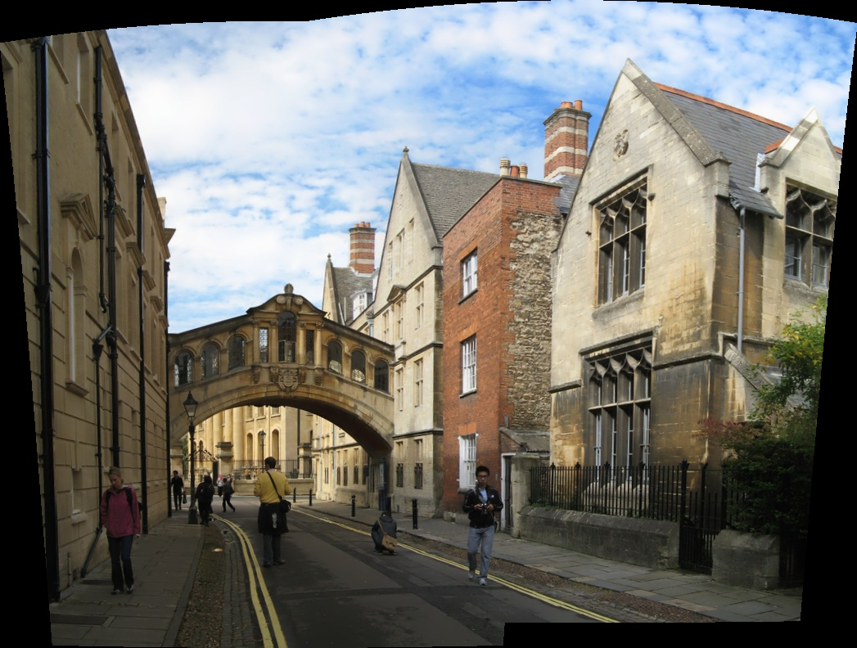

Office: 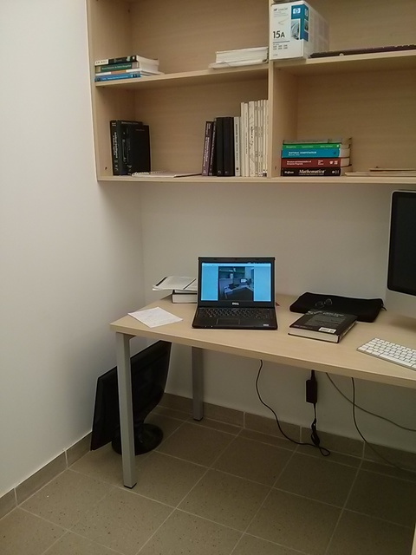

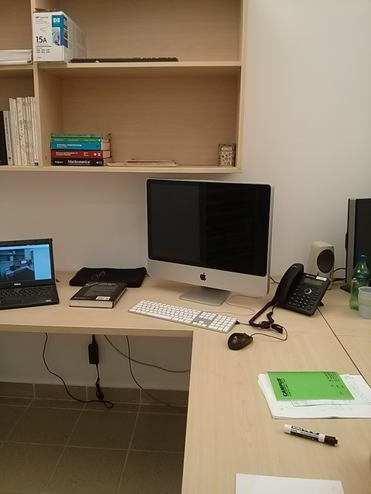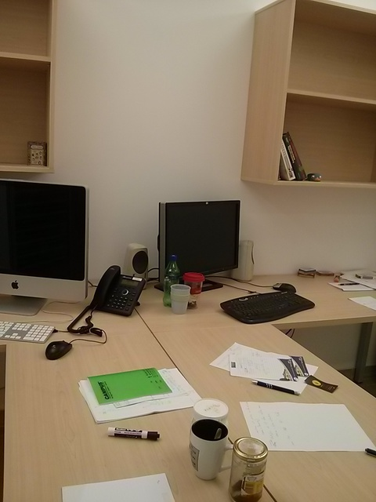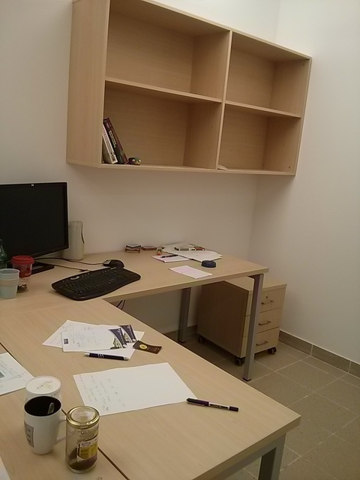

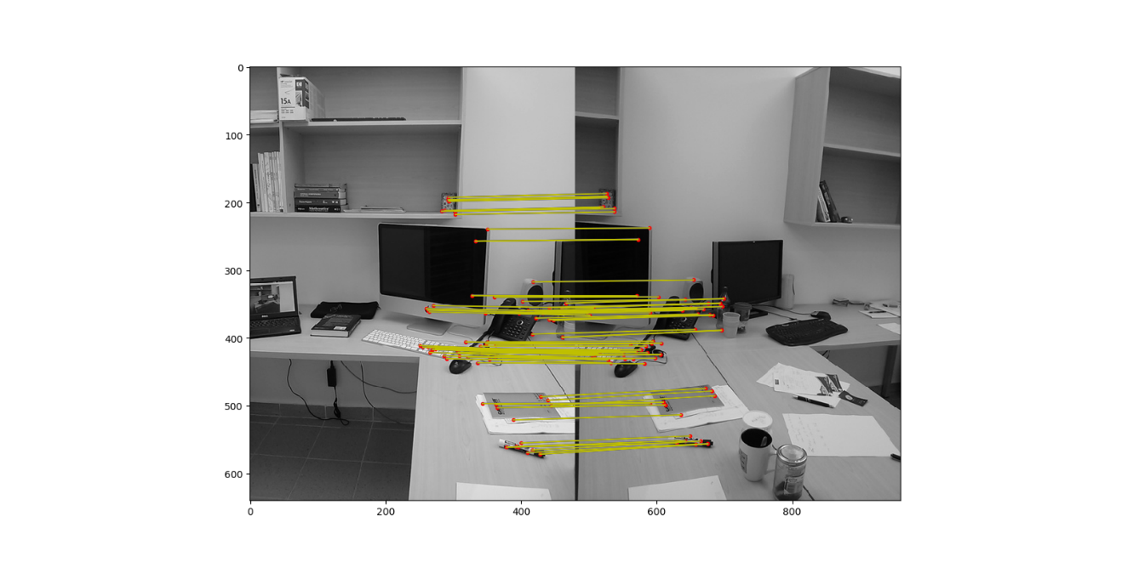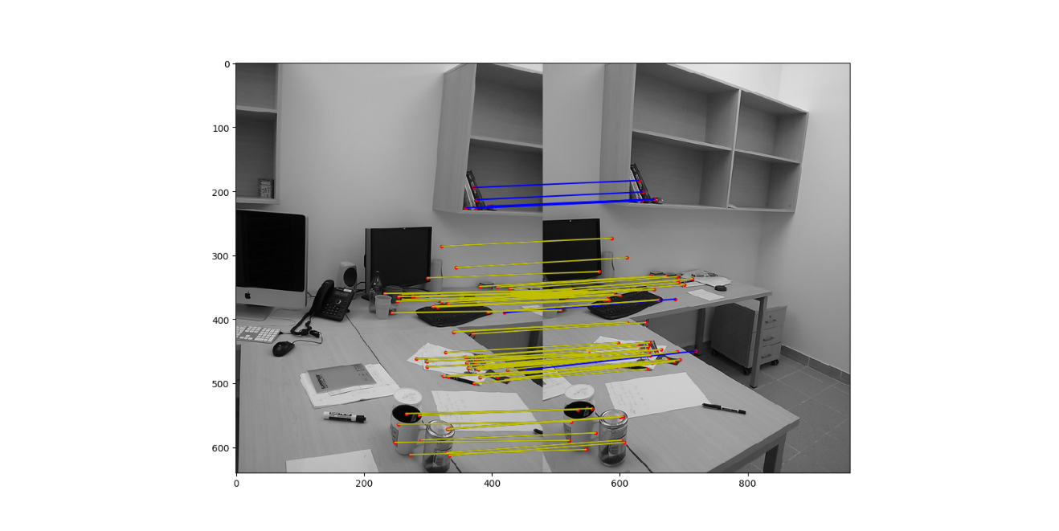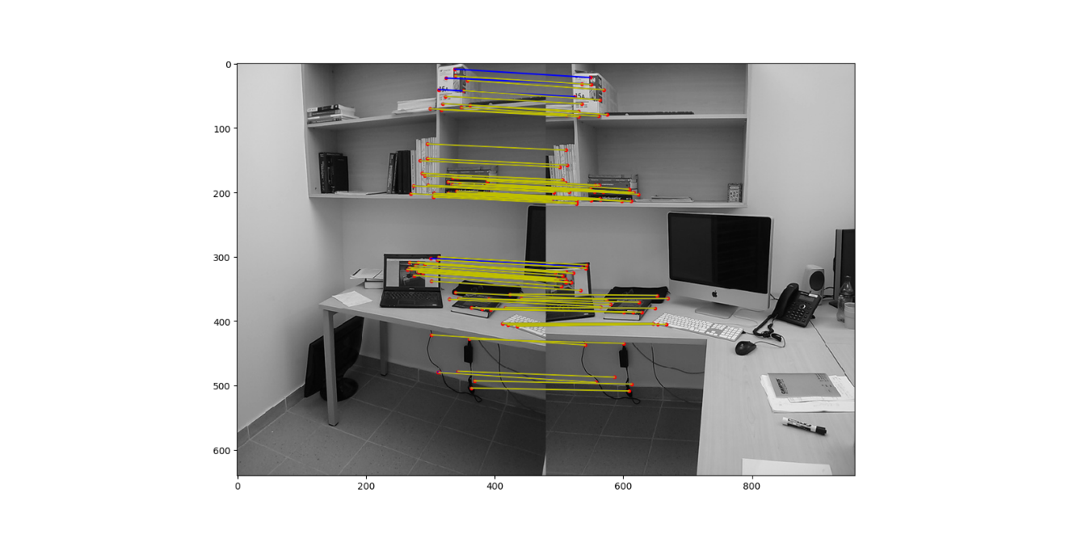

Result:

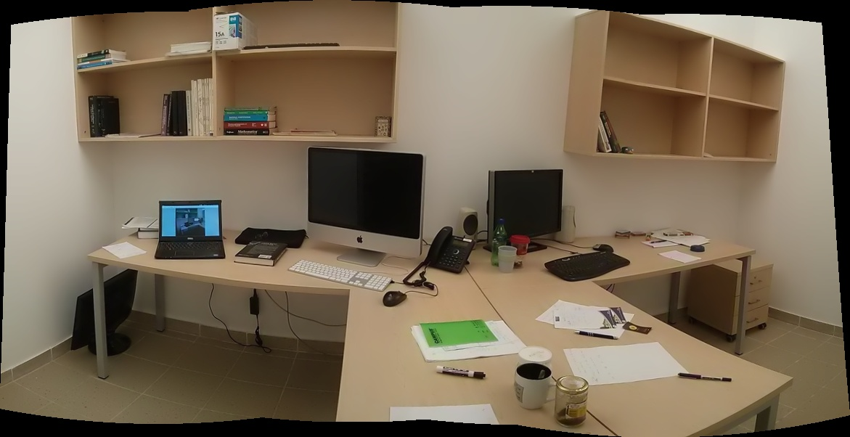

Mine: 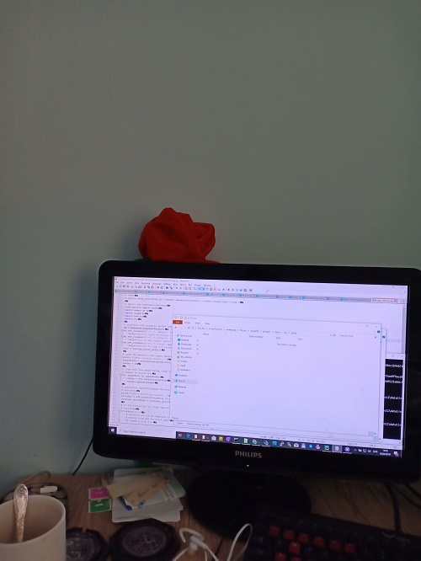

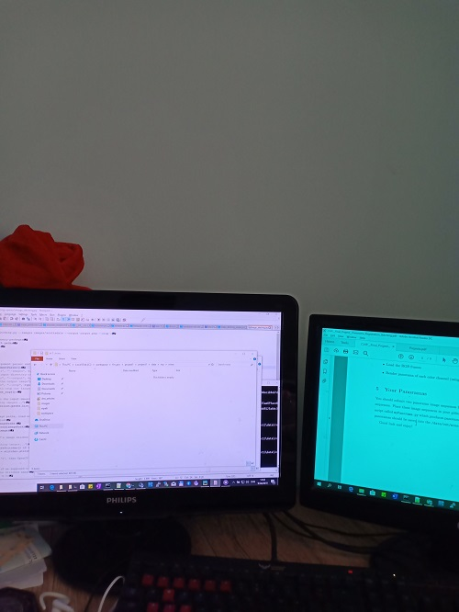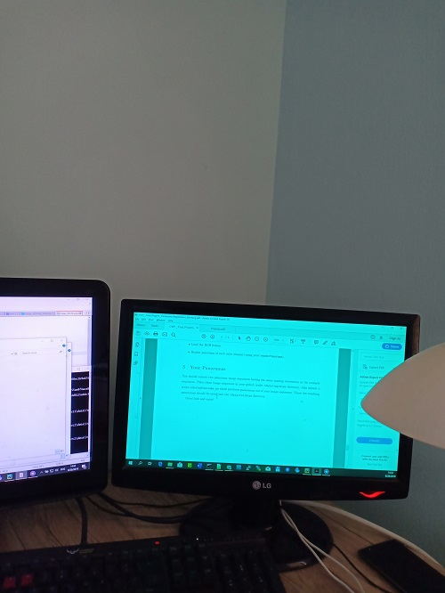

Key points:

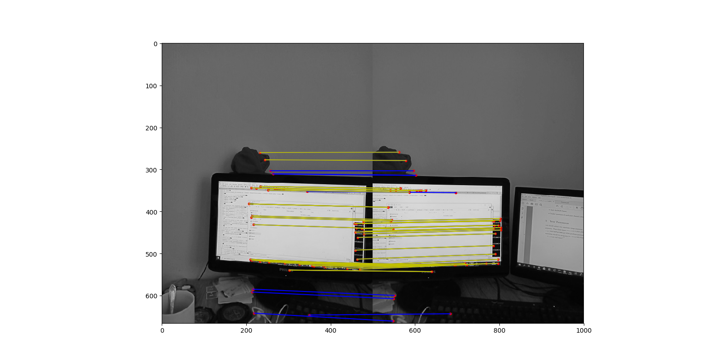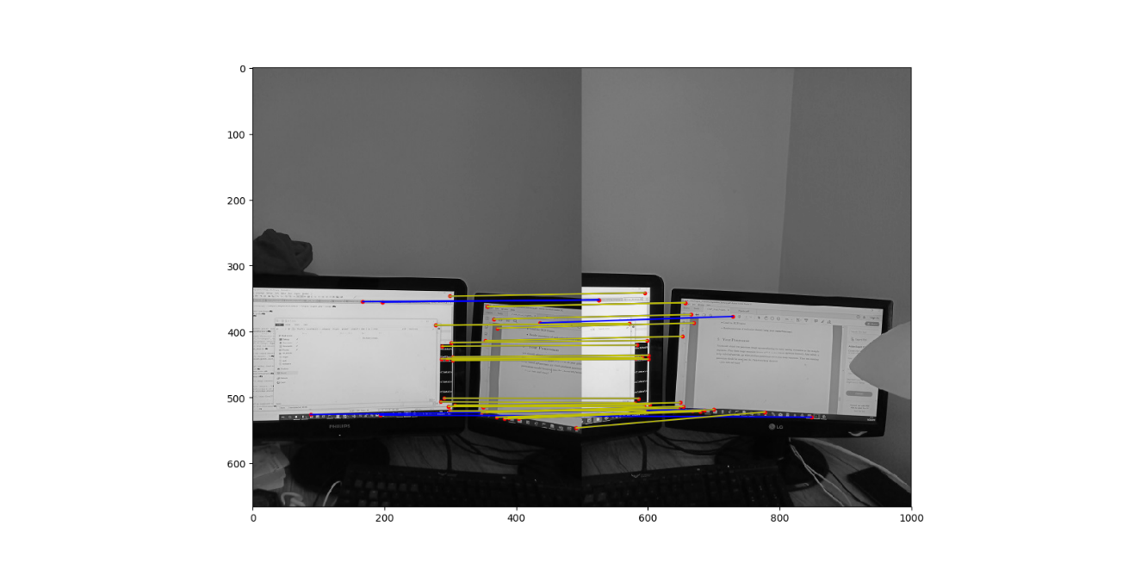

Result:

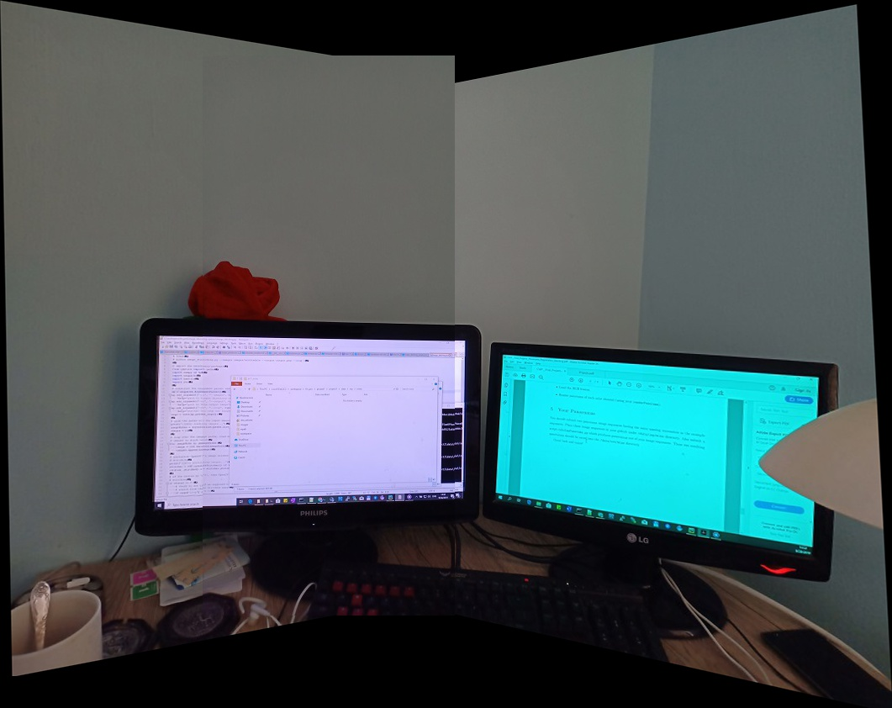

Mine 2:

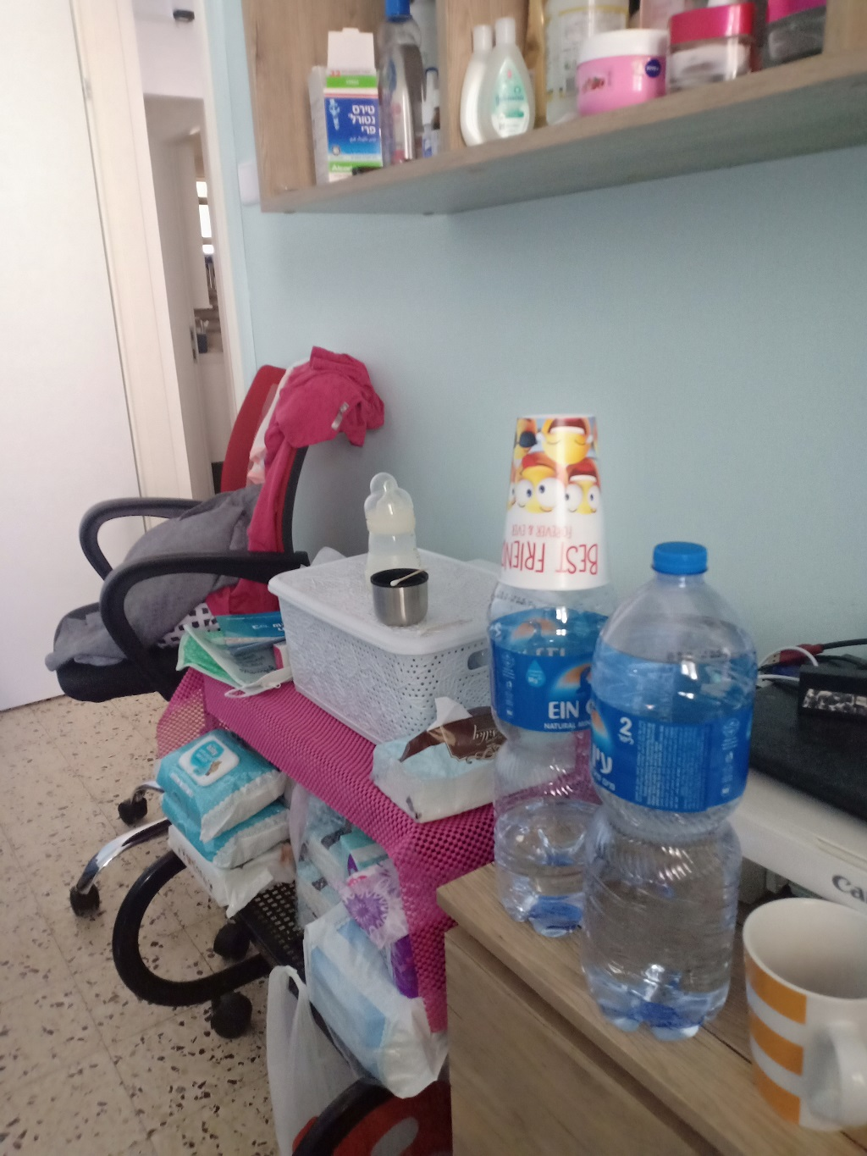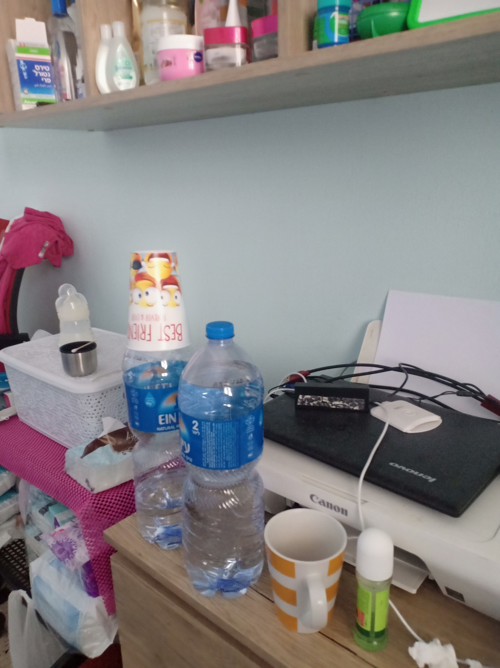

Key points:

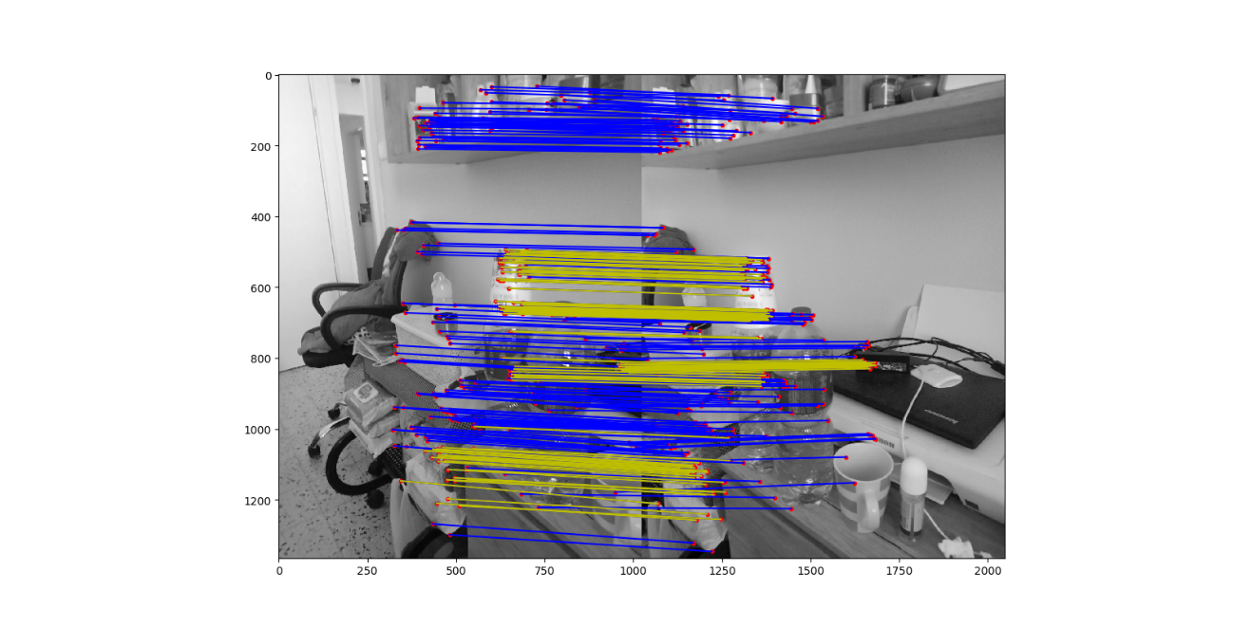

Result: 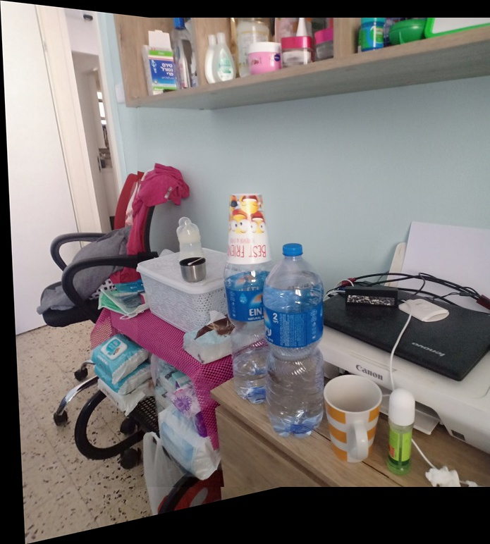

Github:

<https://github.com/Blanksalot/blankprojcv>